Contents of the Documentation

System using PHP and MySQL 1

❖ Setting up our environment 2

❖ Features of the System 7

Admin/Staff Side 7

▪ Login Page 7

Admin 8

Home Page 8

Manage class 8

Manage Batch 10

Manage Teacher 11

Manage Student 12

Manage Attendance Page 13

Manage Report Page 15

Manage Sub-Admin Page 16

Organization info 17

Sub-Admin 18

Class Teacher 19

Home 19

Manage Student 20

Take attendance 21

Manage Schedule 21

Manage Report 23

Student Side 23

Login page 23

View Schedule 24

Report 25

# 

# System using PHP and MySQL

This **System is using PHP and MySQL which** is a simple project that will help a specific school manage their class attendance, schedule and reports. The system has four sides: the school system admin, the schools sub-admin, the school teacher and school student. The system admin can manage all data in the system, including the creating classes, creating batchs, creating teachers and assigning specific teacher on a class, and also registering students. The classes and batchs data are used for the information needed when the attendance, schedule and reports of the class is set for class students.

That **School System** in PHP itself has only a minimum scope but a good start for developing a full system and easy to enhance when you are also planning to add a feature for the schedules of each student for their class. Using this system, the sub-admins can only view attendance records and make the appropriate response to reports and make analysis by downloading the report and they are not responsible for creating and assigning any user in the system, the teachers can only view there students and take attendance of their corresponding students, the students can view their scheduled programs that the teacher assigned and report an issue.

The system requires GD library for generating different image files so enable that. To enable GD library please follow the following method based on the running server

1. If you are working on localhost in your computer using XAMPP.

Step 1 Go to XAMPP and APACHE server

Step 2 Go to config section and select php.ini file

Step 3 Open the file in text editor of your choice

Step 4 Search for GD , and remove the semi colon

Step 5 Save the file and restart your XAMPP

1. If you are running the system in cPanal , please watch the following video to enable GD library

https://www.youtube.com/watch?v=Pf9bxO0aOqs

# Setting up our environment

* First we have to install our server; in our case we would be using XAMPP.

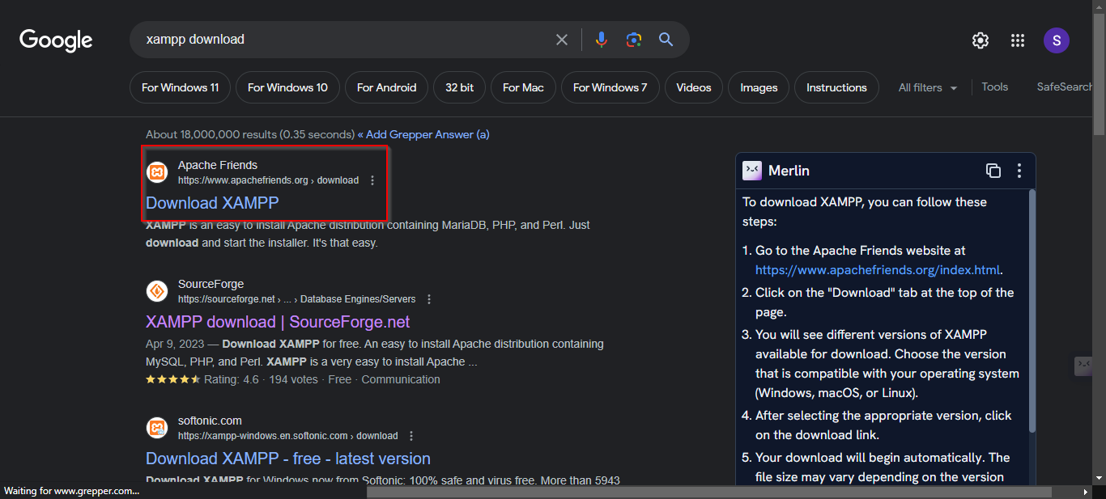

* Then after downloading XAMPP, we have to install it by following each step as the default.
* After that we have to start Apache and MySQL in XAMPP.

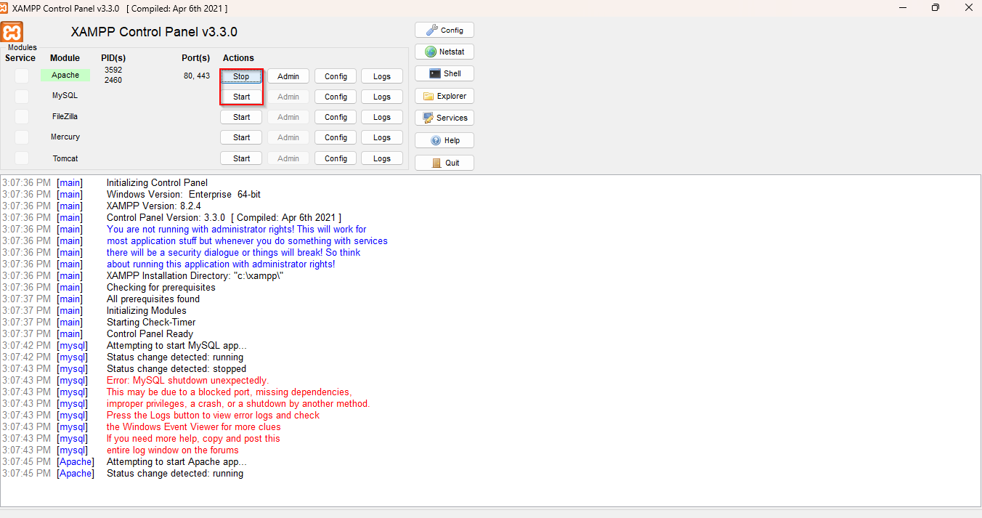

* Then we have to browse for local host in our browser.

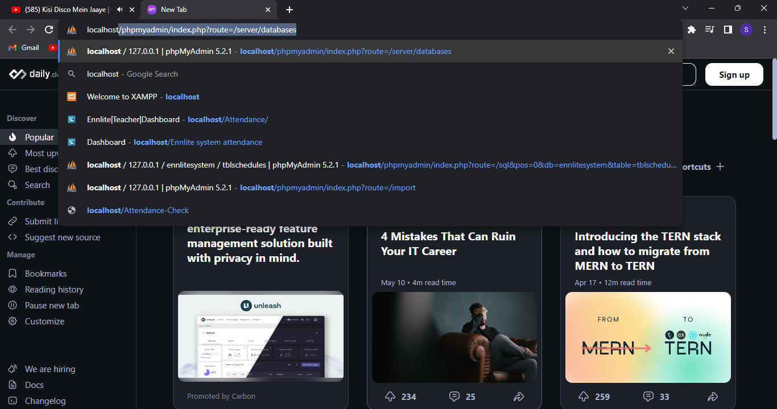

* And then we have to create a database and import our SQL file from the folder where the code is in.

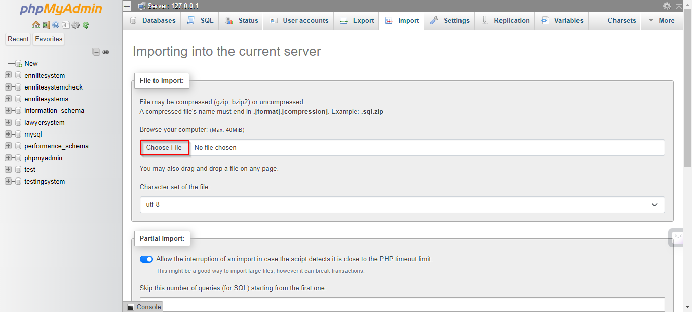

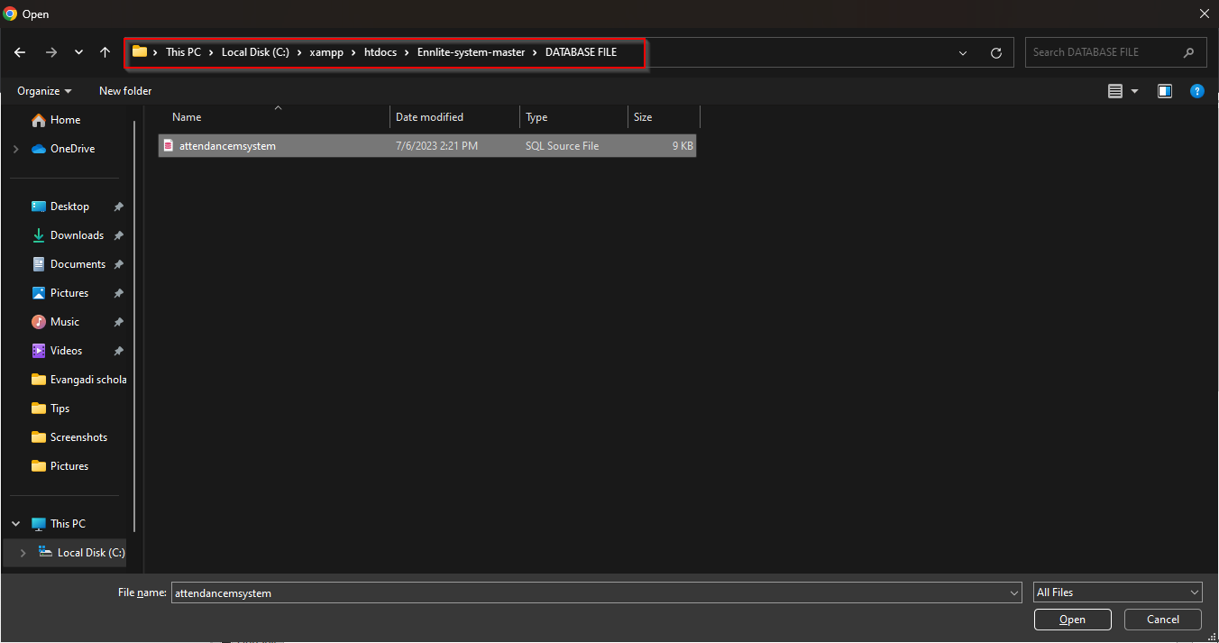

* Then we change the name of the database in the Includes/dbcon.php line 5 by the name of the database we just created.

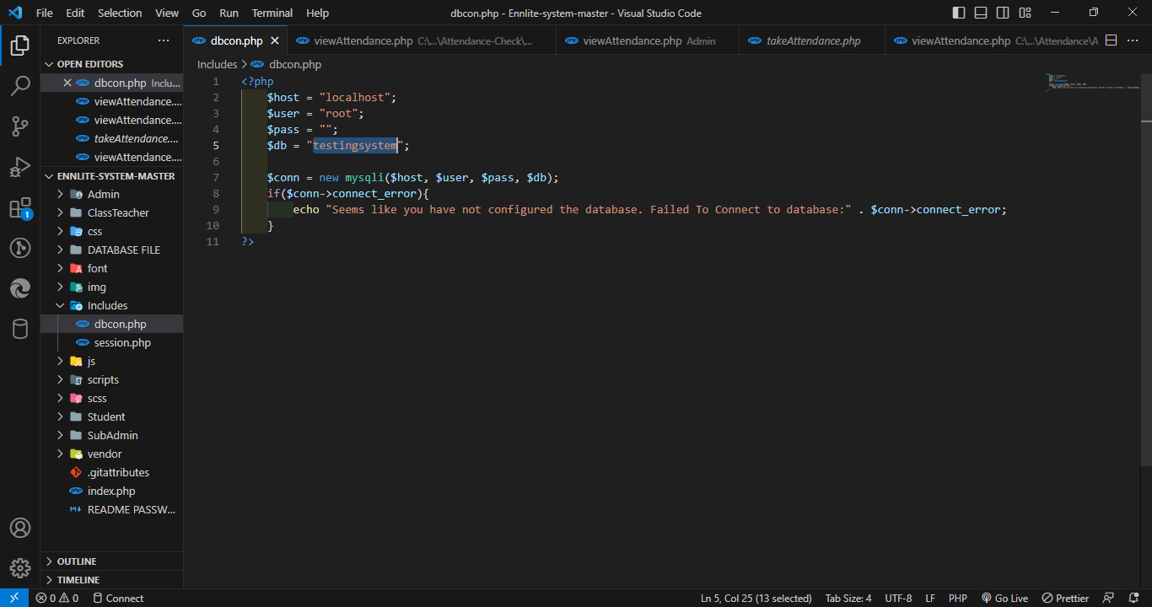

* Then browse, where Ennlite-system-master is the folder the code is in, after localhost.

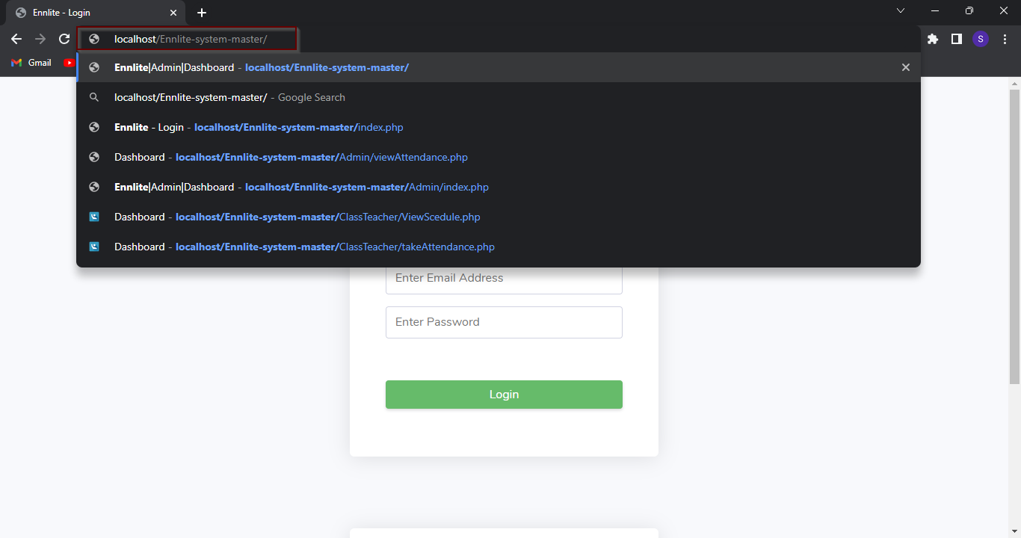

# 

# Features of the System

## Admin/Staff Side

### **Login Page**

* The page where the system admin, sub-admin and teacher submit their email and password to access and manage work.

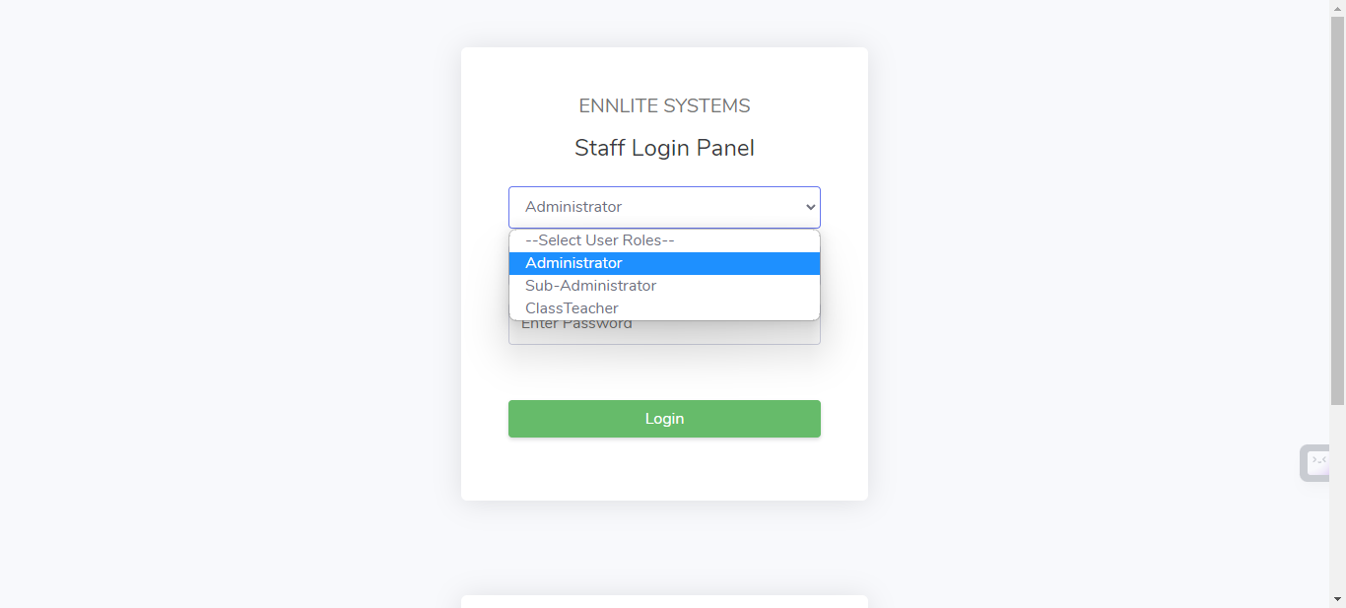

### Admin

#### **Home Page**

* The page where the system admin will be redirected after logging into the system which is the dashboard where the admin can view the total student, teacher registered and also the classes and the batchs present at the current time.

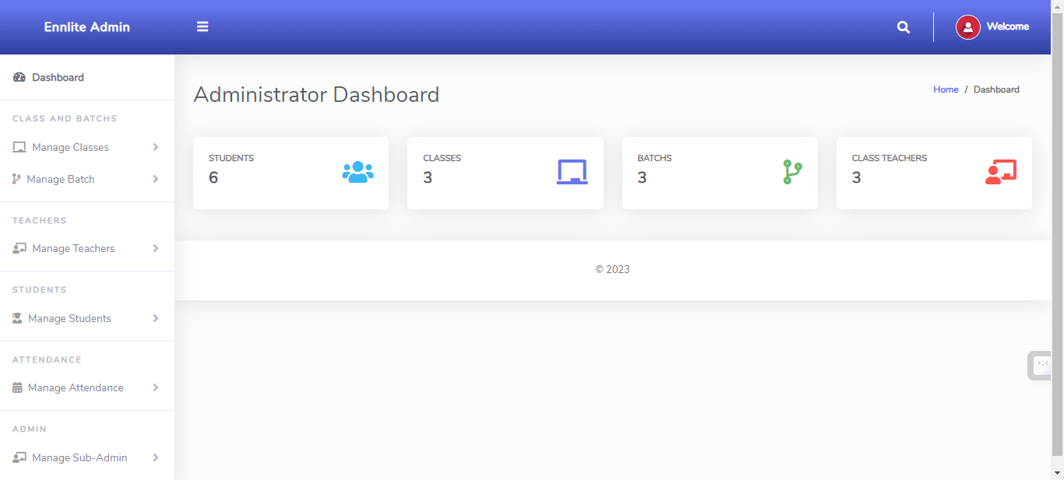

#### **Manage class**

* The page where all school’s classes are listed and managed. The page also consists of a form where admin will be able to register a new class. He/She will be able to edit and delete the classes created.

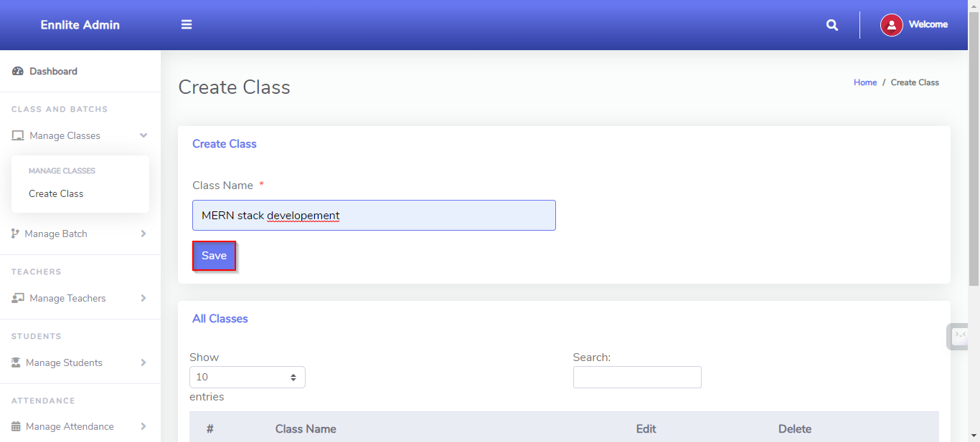

* Here we are going to be updating the class name to MEAN stack development.

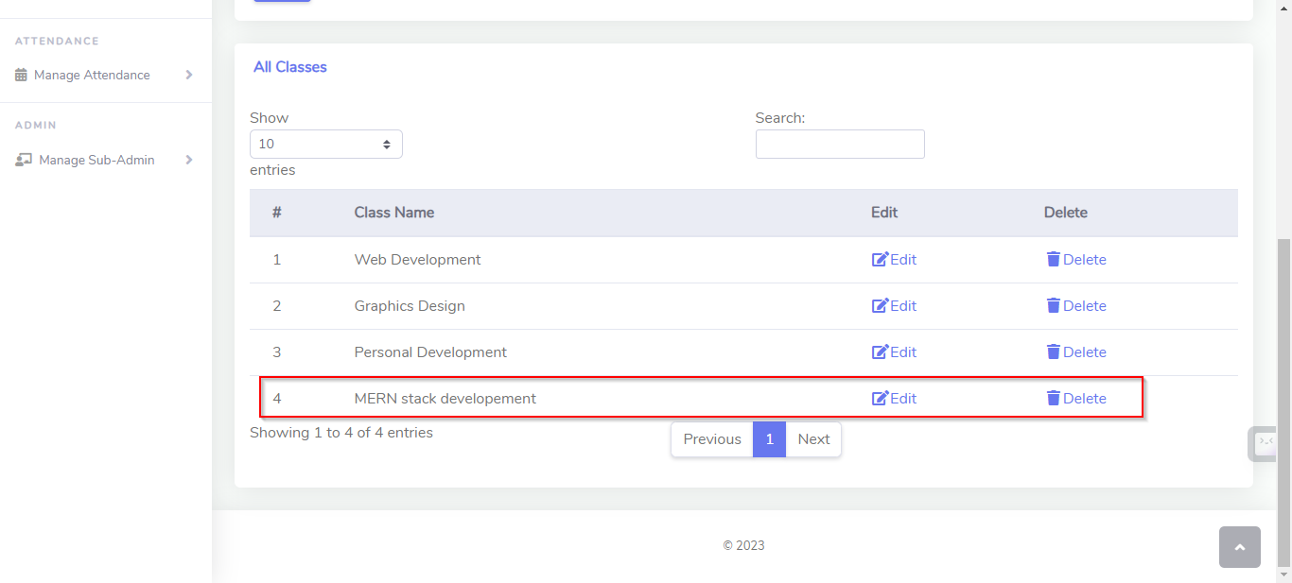

#### **Manage Batch**

* The page where all school’s batchs are listed and managed. Admin will be able to create a batch for the classes available .He/She will be able to edit and delete the batchs created.
* When the batch is created the status column will be set to unassigned by default, it will be changed to assigned as soon as the admin assigns a teacher to that specific batch.
* This page will return “batch already exists” if you try to create two different batchs with the same batch name.

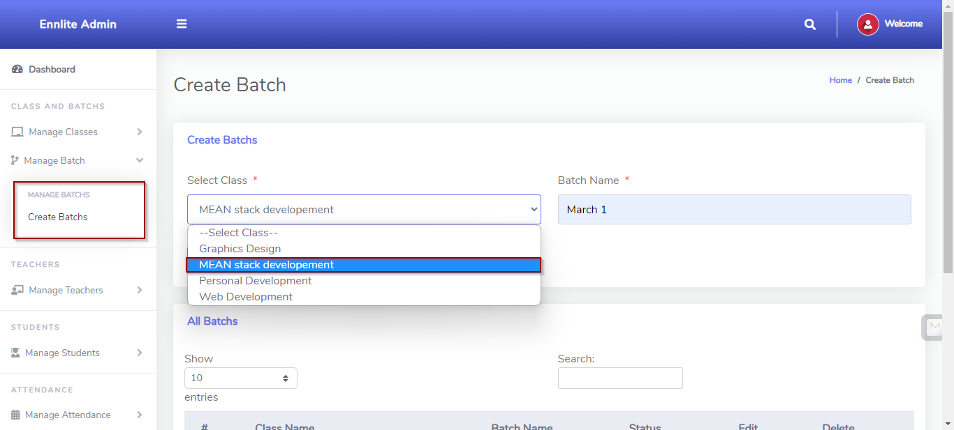

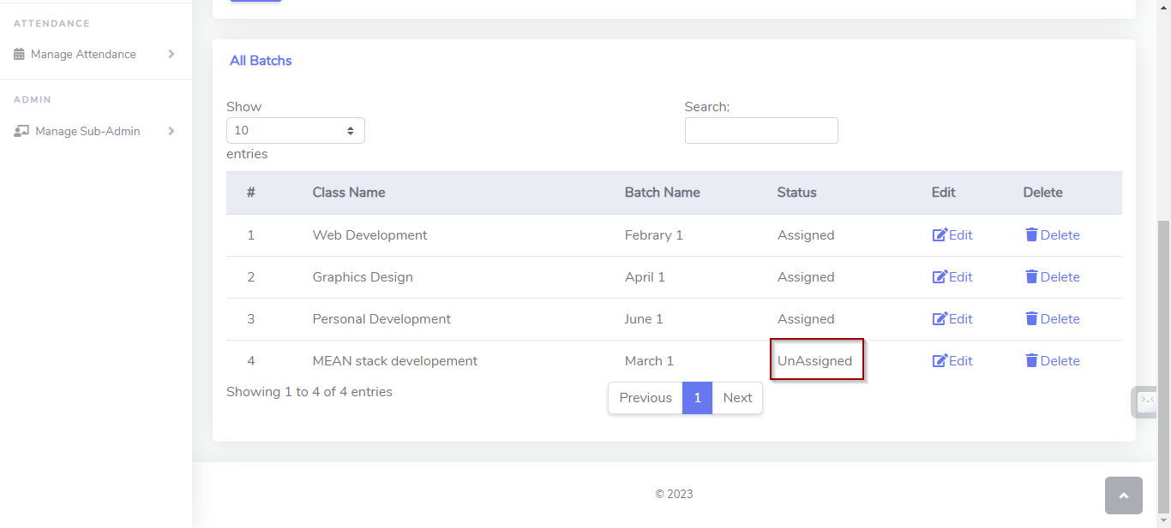

#### **Manage Teacher**

* The page where all school’s teachers are listed and managed. This page also contains a basic form where the admin fill information about the teacher registering to the school.
* Also two teachers can’t be assigned to one batch with the same batch name, Can be assigned if the batch name is made slightly different.
* One teacher can teach many batch with in one class but cannot teach outside of his class.

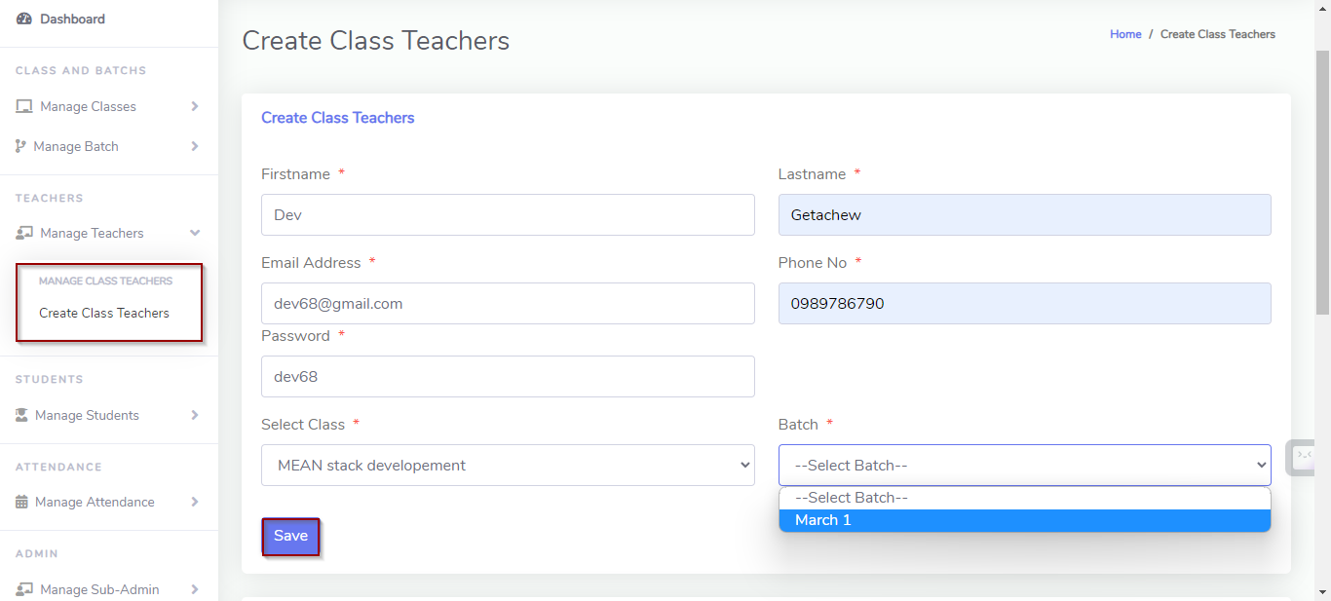

#### **Manage Student**

* The page where the school students are listed and managed, and be able to edit and delete a student.
* This page contains a basic form where the admin fills the information about the student. The admin will choose a class and batchs for that specific student.
* The students’ admission number should be unique so it is automatically generated by the system when the students’ information is saved.
* There is a field where the admin chooses the students profile picture where students’ photo will be sent to be used by the ID that is going to be generated.
* In this page the admin can generate ID cards and also generate Certificates in PDF format.
* When student is registered his ID card will be generated automatically.

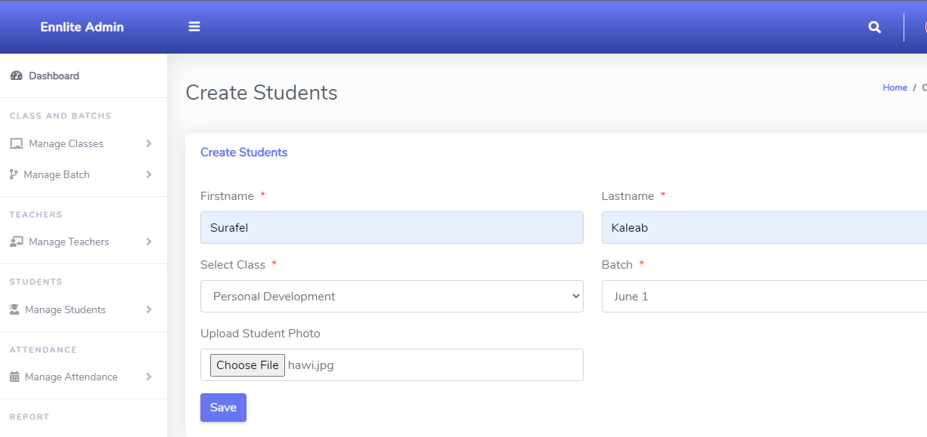

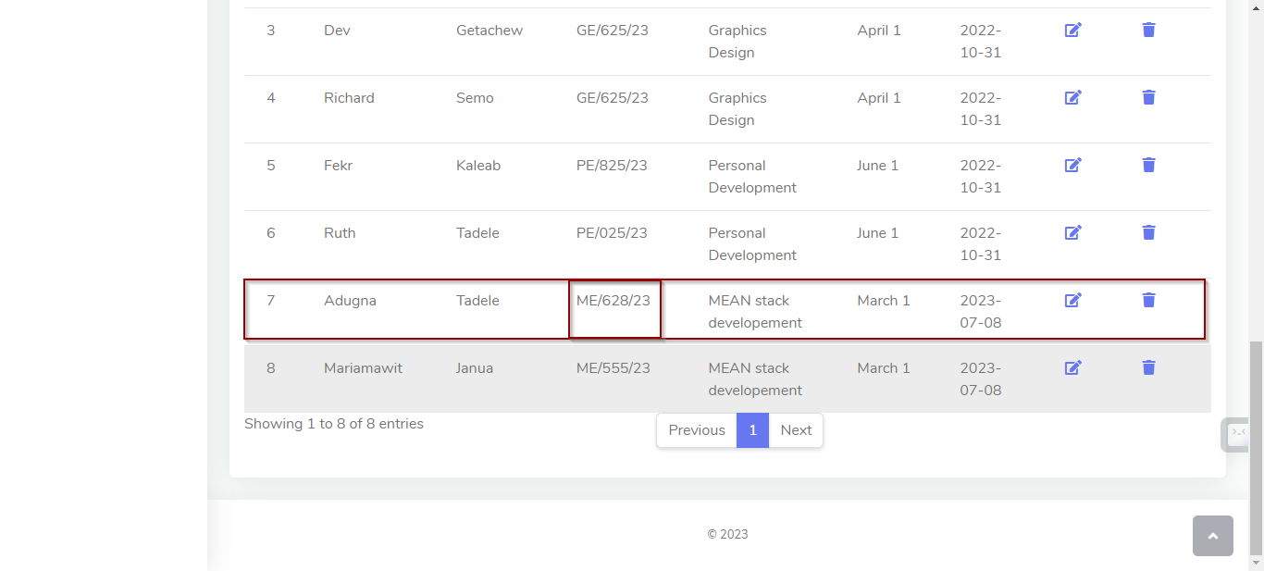

#### 

#### **Manage Attendance Page**

* The page where the system admin and sub-admin manages the attendance of each class and there students.
* It allows choosing from the date where the admin wants to see attendance of.
* Namely 1, All: The attendance record where the sum of present and absent are displayed.

2, Single date: where admin has to choose the specific date.

3, Date range: where range from date and to date is chosen and the system will display the attendance record of that specific range of dates.

* Also has a report section where the attendance report is generated using excel, if no attendance is taken it will not display anything.

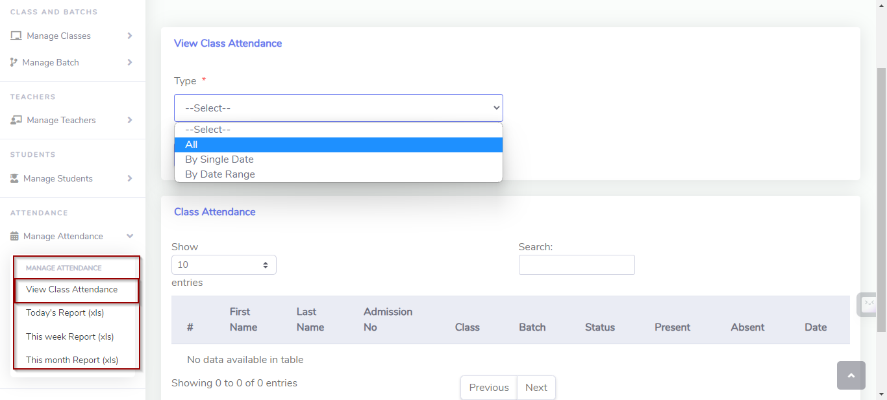

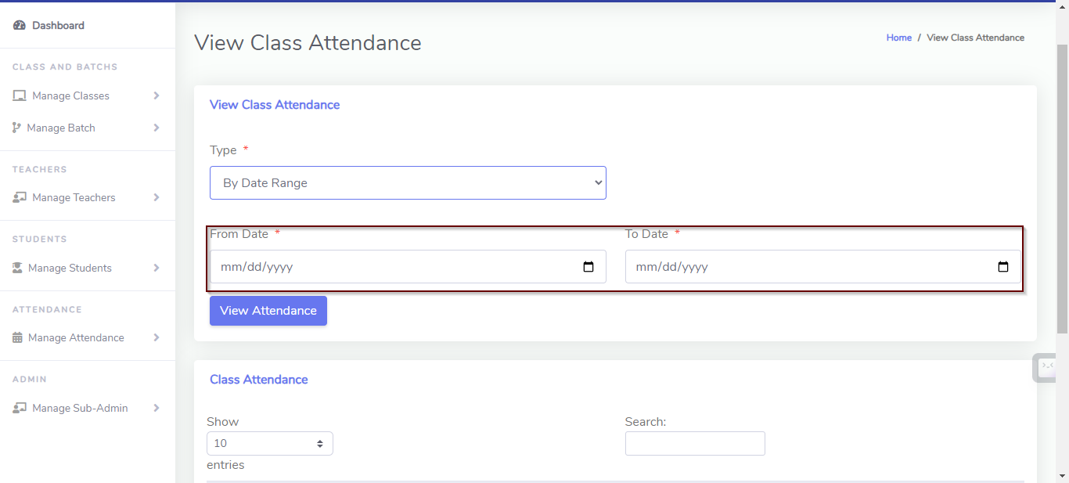

#### **Manage Report Page**

* **This is a page where the view the report that has been made from the student to the academy.**
* **The admin can view the report and make a response to it. By default the report will be on-progress and if the admin wants to solve the issue raised, they can tab the handle link and the on-progress will be changed to handling which will be sent to the student who reported the issue.**

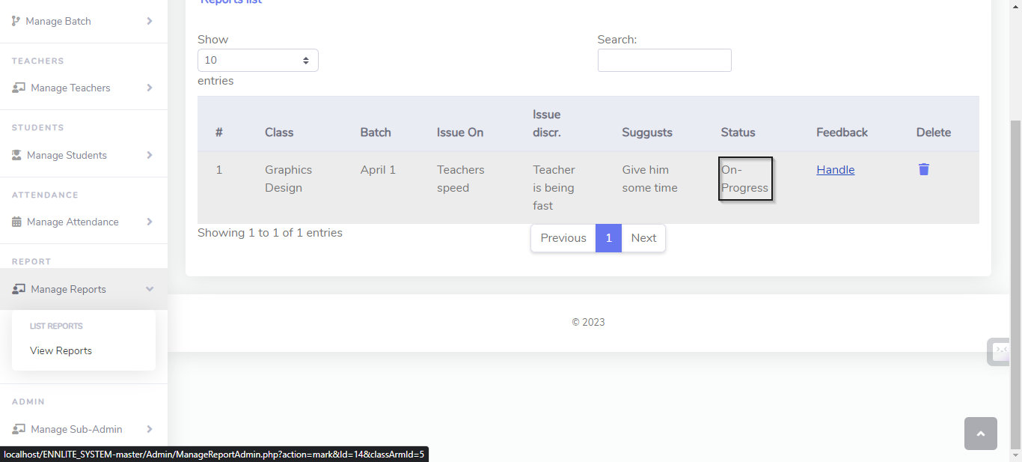

* **To handle unwanted behavior and spam reports of some student the admin will have the power to view who raised the report in the database. However it will not be displayed in the main Manage report page to keep the students privacy.**

#### **Manage Sub-Admin Page**

* **This is a page where the admin assigns another sub-admin to handle the attendance recorded.**
* **The page contains basic form where the admin fills with the information about the sub-admin, and also a table that contains sub-admin information and be able to view, edit and delete.** 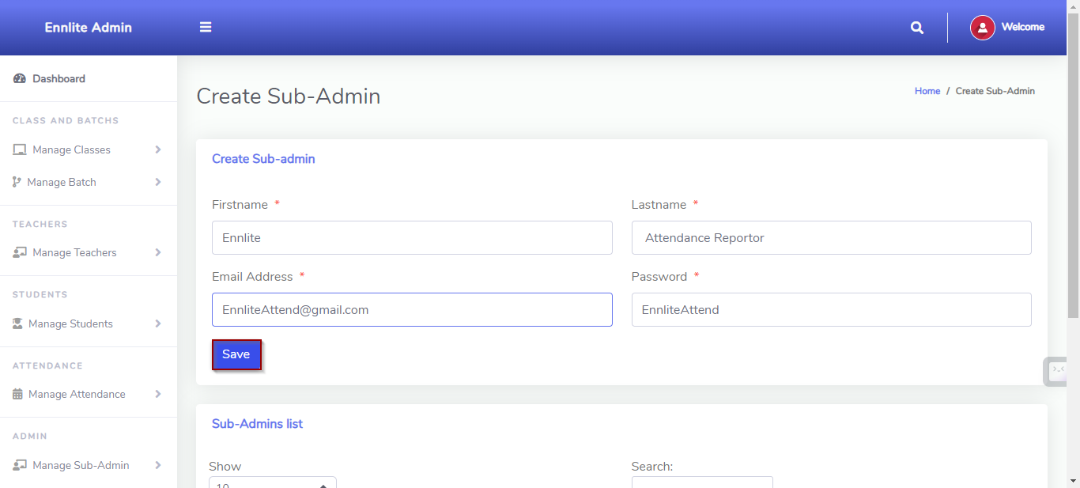

#### Organization info

* This is a page where the organization fills there information where it will be displayed on ID generated and Certificate generated for the student.
* There is an input where the organization chooses a template where it will be used.
* They should choose a template which is the same orientation as the previous templates to not distort the ID or Certificates being generated.
* Organizations can change there information in profile section in top bar.

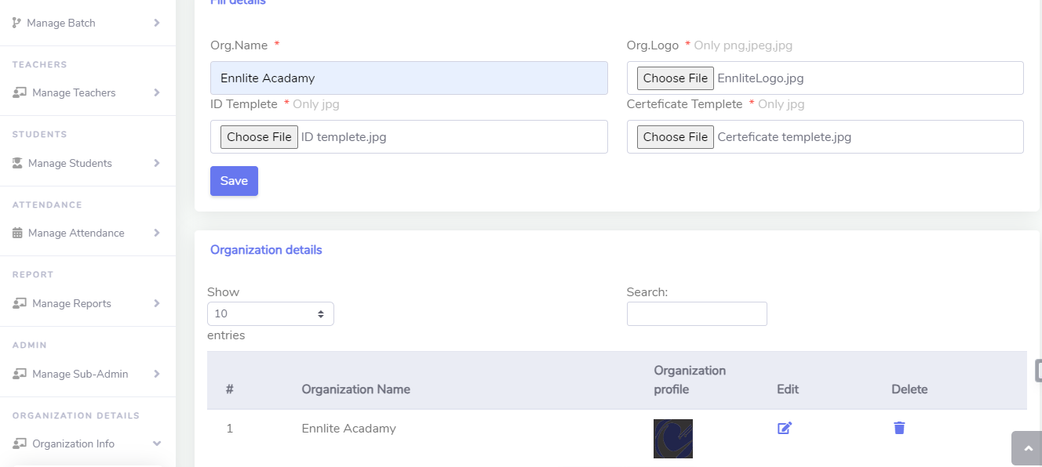

### Sub-Admin

* This Sub-Admin is created by the admin to support on managing only the attendance and the reports that has been made on the academy.
* Can’t create anything only view the created.
* Same as the admin but its only job is to generate a record of attendance, make the appropriate response to reports made and make analysis.

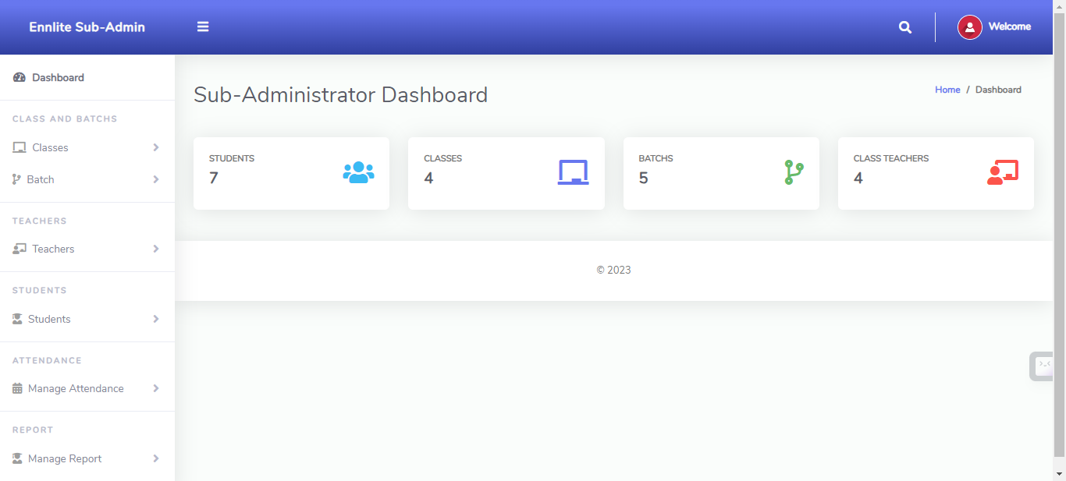

### Class Teacher

#### Home

* The page where the system teacher will be redirected after logging into the system which is the dashboard where the teacher can view the total student and also attendance taken until the current time, and how many batch’s are available.

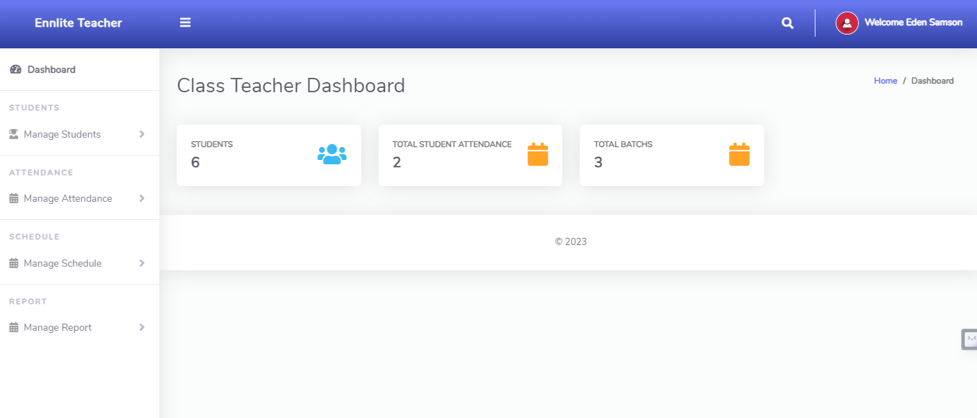

#### Manage Student

* Page where the teacher views his student

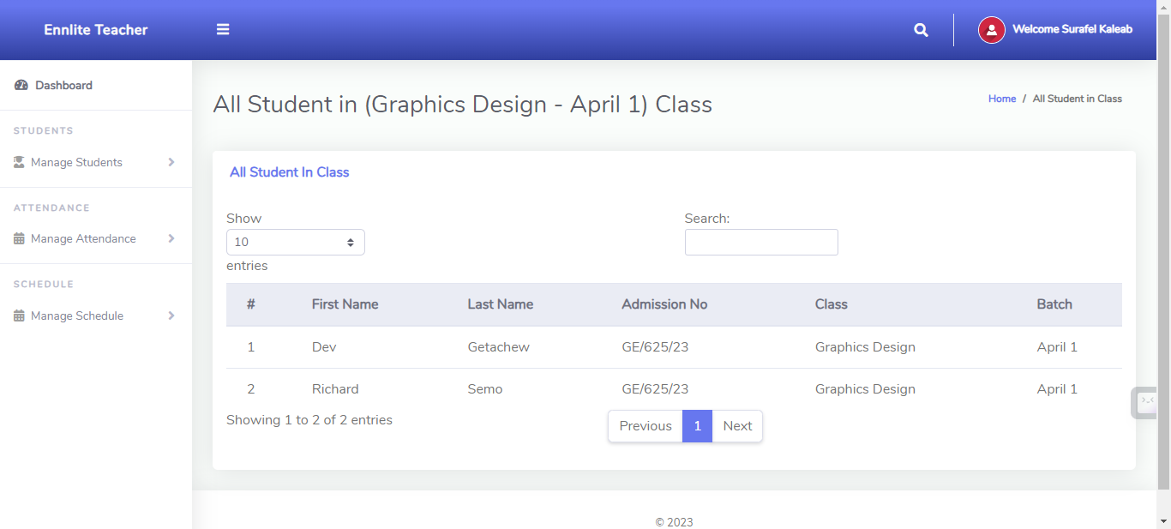

#### 

#### Take attendance

* Page where the teacher takes the attendance for his classes available to him.
* He chooses his class and takes the attendance of his choice.
* Attendance can’t be taken twice for one day for one class but can take multiple attendances of his other batch’s.

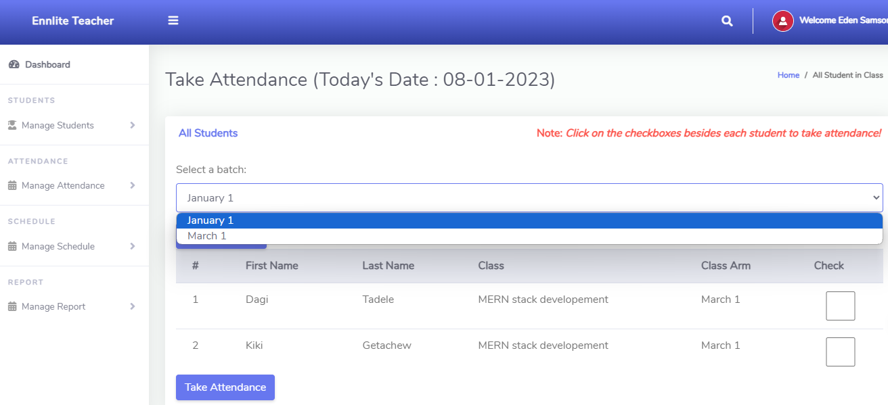

#### Manage Schedule

* The page where all the teacher schedule are listed and managed. The page also consists of a form where teacher will be able to schedule a program. He/She will be able to view the schedules created.
* The pages form is all the information a schedule should have, and the teacher has to choose if the schedule is for a specific date or for a weekly schedule.
* Teachers can share a link and a document to help students.

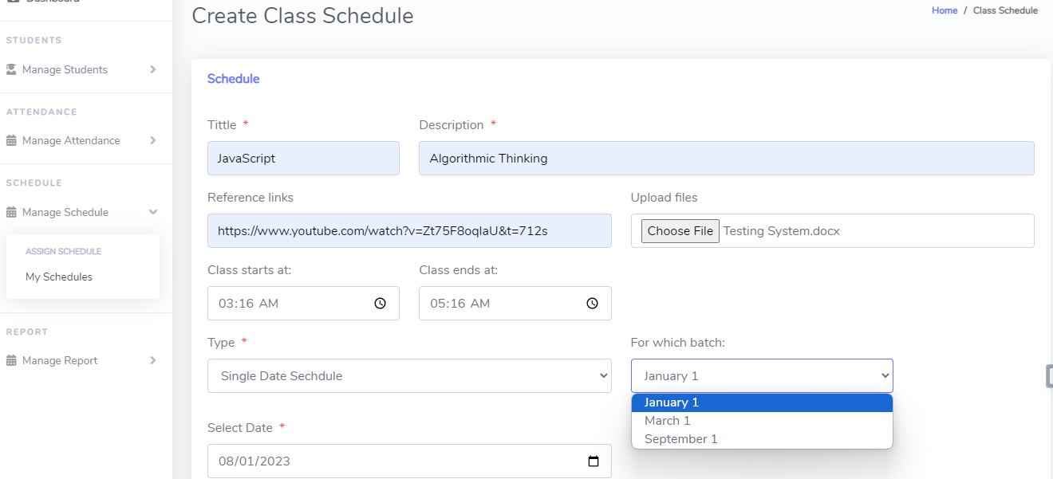

* Teachers can choose for which for which class he/she wants to set the schedule to.
* Teachers can also view their own schedule by choosing from options.

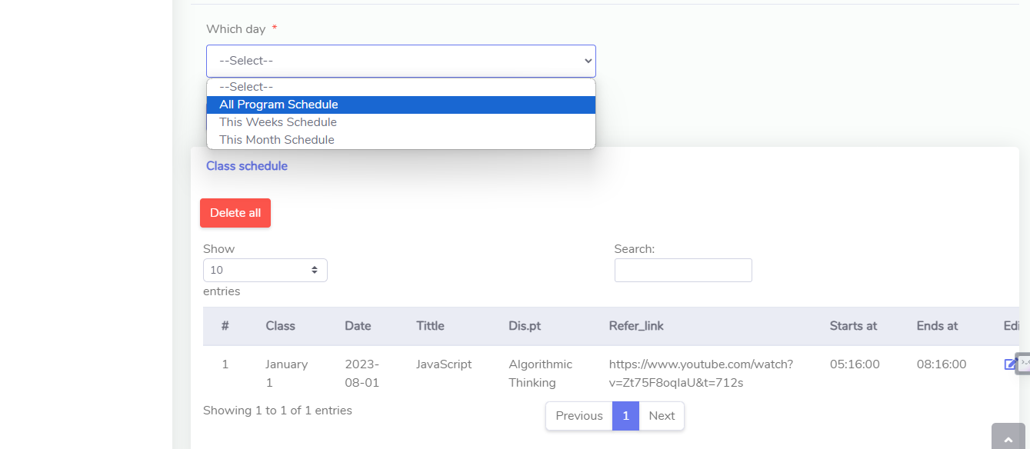

#### 

#### Manage Report

* This is a page where the teacher can view the reports that have been sent to him by his students.
* The teacher can view and hit the handle link to let his students know that he is handling the issue they raised.

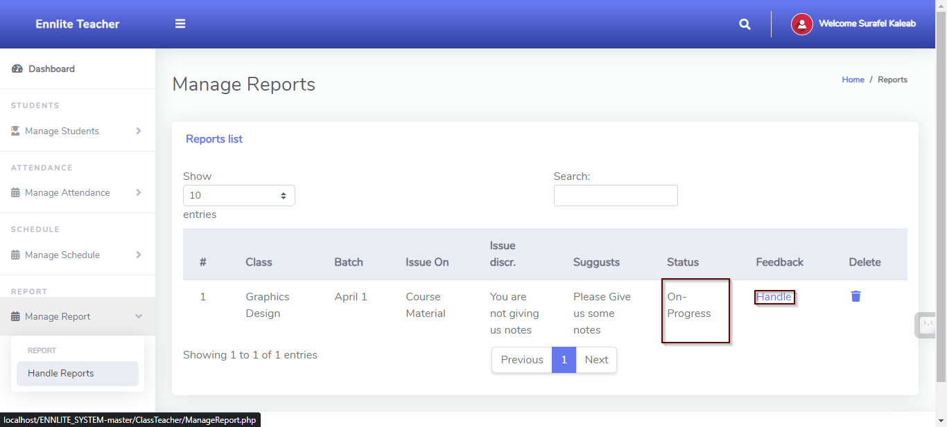

## 

## Student Side

### Login page

* The page where students submit their admission number to access their account.

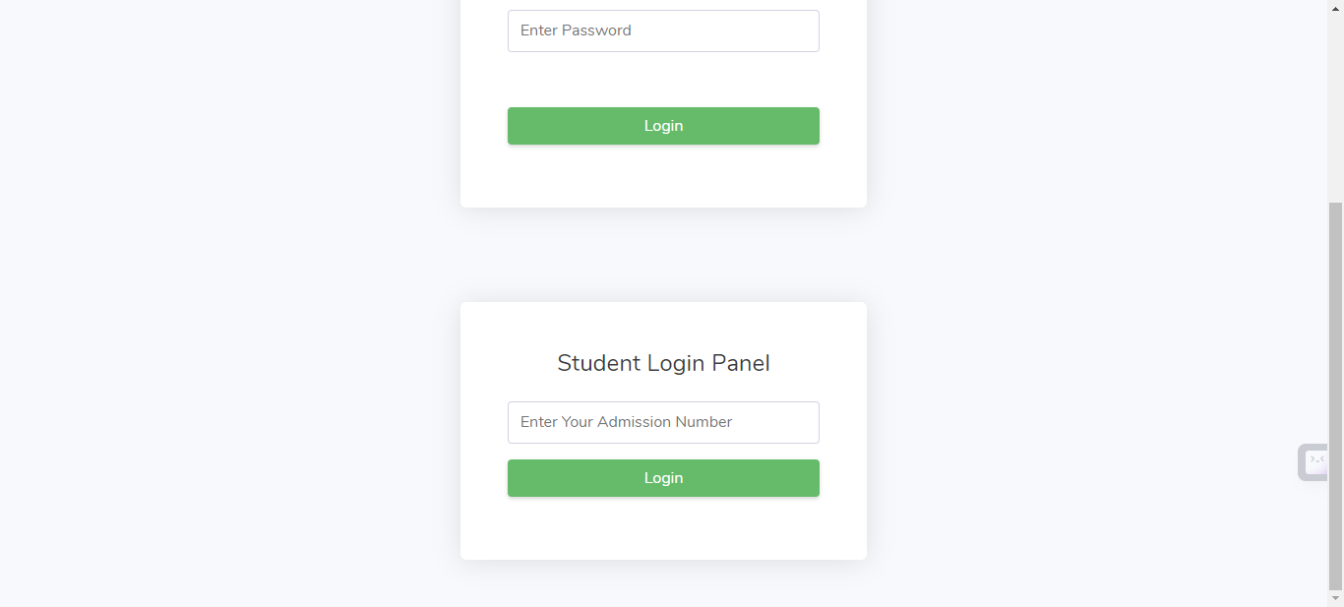

### View Schedule

* This is a page where student can view the schedules assigned to him/her.
* In this they have three options

1. All programs – where they view all the schedules until the current date.
2. This week – where it displays the entire schedule in that specific week (Mon - Sun).
3. This month – where it displays the entire schedule in that specific month.

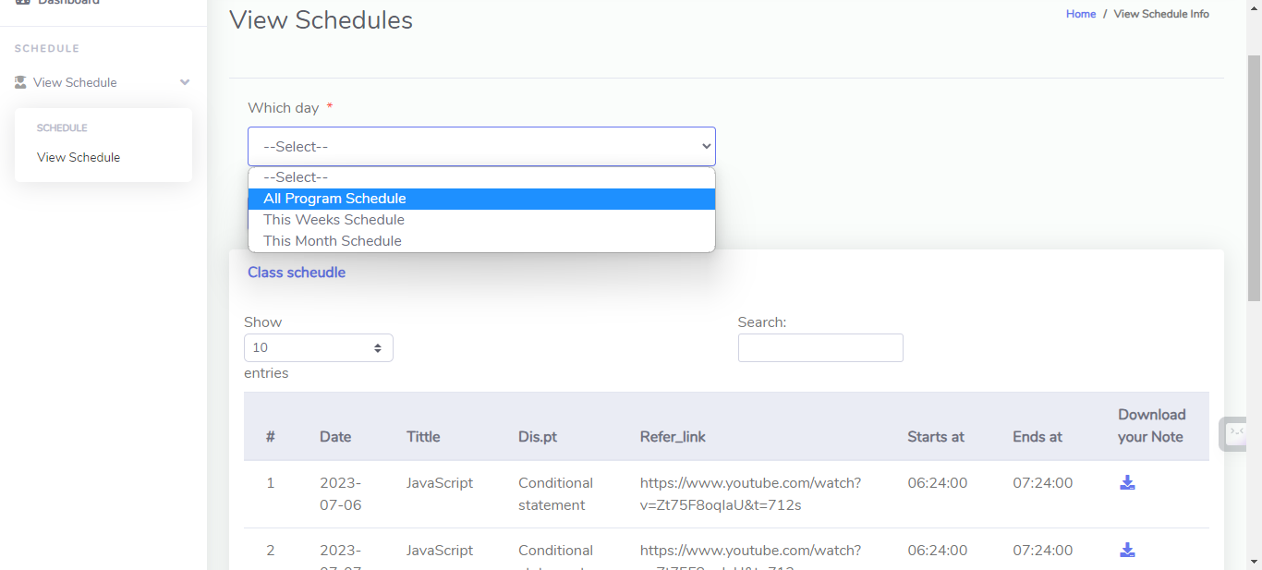

* The students can refer the link and also download the file that is sent from the teacher to refer.

#### Report

* In this page student will be allowed to raise the issue they are not comfortable at.
* They can send the report to their instructor or they can even send the report to the academy, if there issue is not solved with their instructor.
* The students will have a chance to view the reports they made so far and also view there reports status.
* If the status is on-progress it means the report is not seen, However if the status field says handling, there issue is being handled by whomever they sent there report to.

